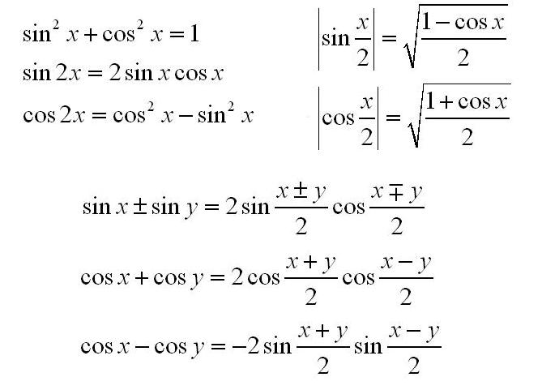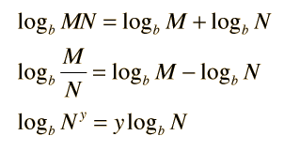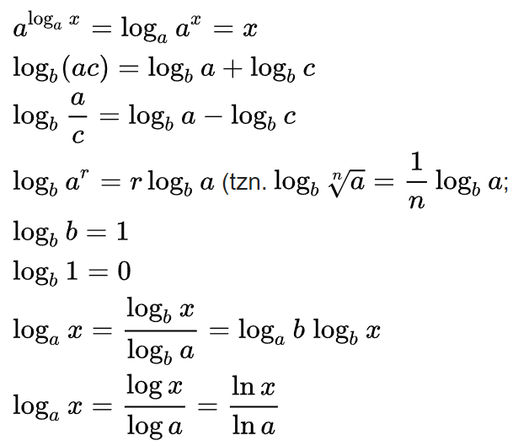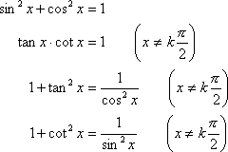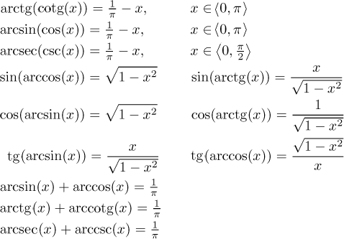

Nedefinováno:

|  |  |
| --- | --- |
| $$0^{0}$$ | $$1^{∞}$$ |
| $$\frac{0}{0}$$ | $$\frac{∞}{∞}$$ |
| $$0*∞$$ | $$∞–∞$$ |
| $$∞^{0}$$ | $$\sqrt[0]{x }$$ |

$a^{b}=e^{b\ln{a}}$

$\exp\left(x\right)=e^{x}$

${\left|x\right|}^{'}=\left\{\begin{aligned} 1,x>0 \\ -1,x<0\end{aligned}\right.$

${f^{'}}_{-}\left(x_{0}\right)=\lim_{Δx→0^{-}}{\frac{f\left(x_{0}+Δx\right)-f\left(x_{0}\right)}{Δx}}$

${f^{'}}_{+}\left(x_{0}\right)=\lim_{Δx→0^{+}}{\frac{f\left(x_{0}+Δx\right)-f\left(x_{0}\right)}{Δx}}$

$\lim_{x→0^{-}}{sgn\left(x\right)=-1}$

$\lim_{x→0^{+}}{sgn\left(x\right)=1}$

sgn(0) = 0

$x=sgn\left(x\right)*|x|$

L'Hospitalovo pravidlo

$f\left(x_{0}\right)=g\left(x_{0}\right)=0=>\lim_{x→x_{0}}{\frac{f\left(x\right)}{g\left(x\right)}}= \lim_{x→x_{0}}{\frac{f\left(x\right)'}{g\left(x\right)'}}$

($f(g(x)))'=f'(g(x))⋅g'(x)$

${(c}^{x})'=c^{x} ln⁡c ; c>0$

(ex)' = ex

(sin x)' = cos x

(cos x)' = -sin x

(tan x)' = $\frac{1}{\cos^{2}{x }}$

(cotan x)' = - $\frac{1}{\sin^{2}{x}}$

(arcsin x)' = $\frac{1}{\sqrt{1-x^{2}}}$

(arccos x)' = $-\frac{1}{\sqrt{1-x^{2}}}$

(arctan x)' = $\frac{1}{1+x^{2}}$

(arccotan x)' = $-\frac{1}{1+x^{2}}$

**Derivace**

c′=0

x′=1

$(cx)'={cx}^{c-1}$

$(f(x) + g(x))' = f(x)' + g(x)'$

$(c*f(x))' = c * f(x)'$

${\left(f\left(x\right)*g\left(x\right)\right)}^{'}=f{\left(x\right)}^{'}*g\left(x\right)+f\left(x\right)*g(x)'$

${\left(\frac{f(x)}{g(x)}\right)}^{'}=\frac{{f(x)}^{'}*g(x) - f(x)*{g(x)}^{'}}{{ g(x)}^{2}}$

**Konvergence řad**

Leibnizova věta

${lim a_{n}= 0 \& a_{n}>0 \& a_{n} ≥a_{n+1}=>∑\left(-1\right)}^{n}a_{n} K$

srovnávací kritérium

$a_{n}< b_{n}$ <=> $\sum{b_{n} K}=> \sum{a_{n} K}$, $\sum{a_{n} D}$ => $\sum{a_{n} D}$

Cauchyho kritérium

an >0& $\lim_{n→∞}{\sqrt[n]{a_{n}}}=k$ <=> k <1 => ∑ **K**, k >1 => ∑ **D**

d’Alembertovo kritérium

an >0& $\lim_{n→∞}{\frac{a_{n+1}}{a_{n}}}=k$ <=> k <1 => ∑ **K**, k >1 => ∑ **D**

(Raabeovo kritérium)

an >0& $\lim_{n→∞}n\left(\frac{a_{n}}{a_{n+1}}-1\right)=k <=>$ k <1 => ∑ **D** , k >1 => ∑ **K**